Event Management Application – Test Case Scope
Objective
Create comprehensive test cases for the Event Management application, covering all functional, UI, validation, negative, boundary, integration, security, compatibility, accessibility, performance, and end-to-end scenarios.

User Types
The application supports the following user types:
- Exhibitor
- Third-Party User
Test scenarios should be created for both user types wherever applicable.

Core Functionalities
The test cases should cover the following application features:
- Secure application access using a password page
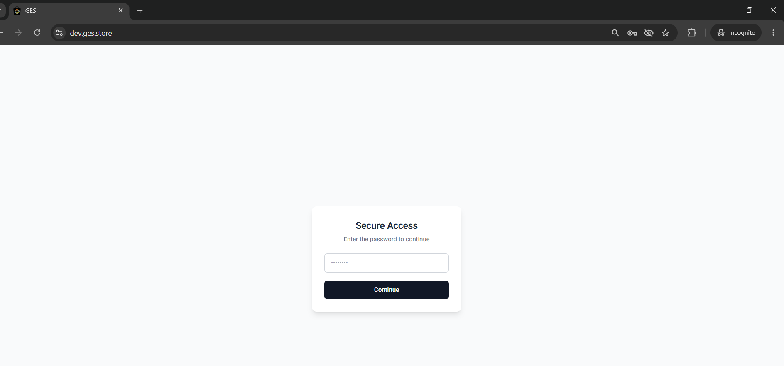

- Search for an event/show
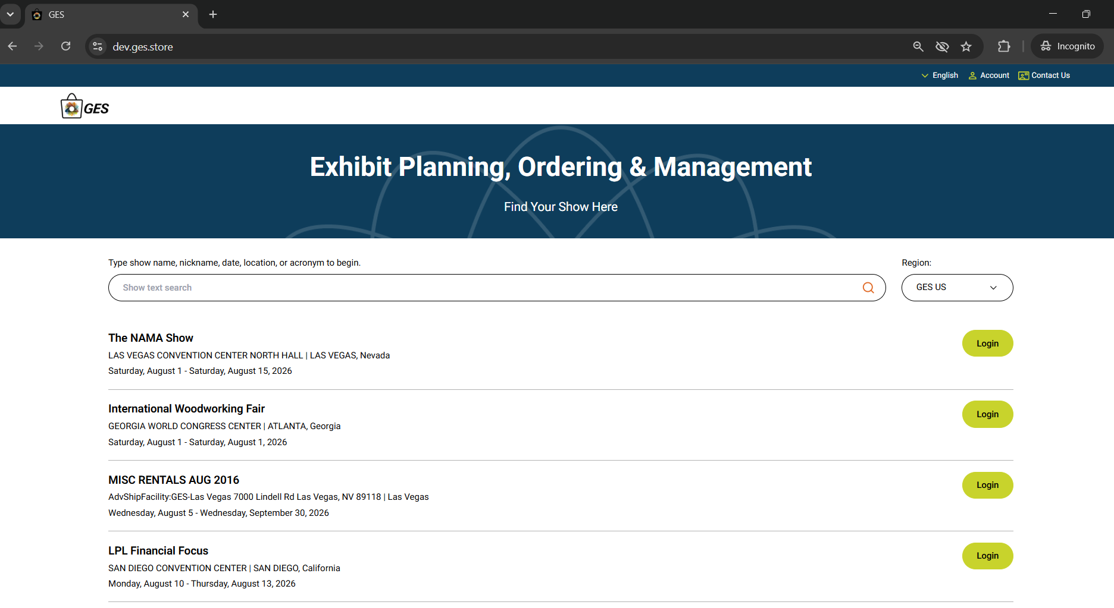

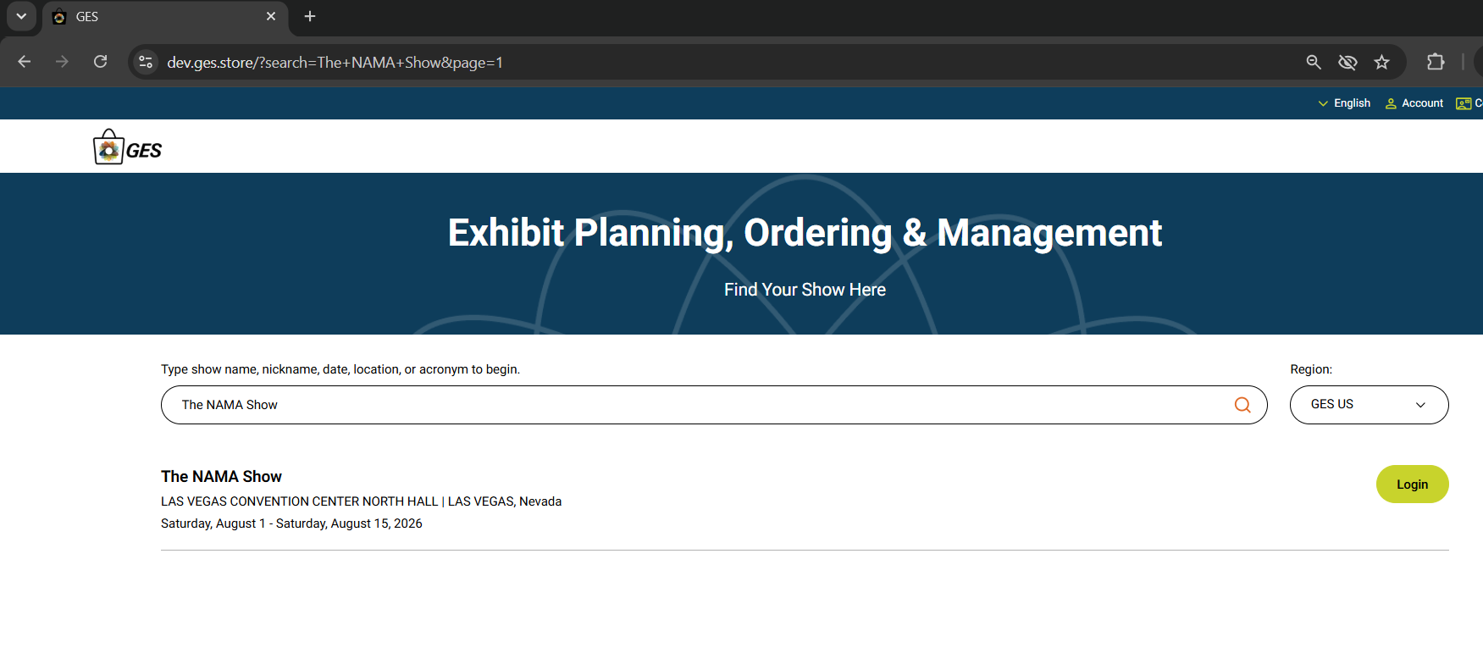

- User authentication (Application Login)
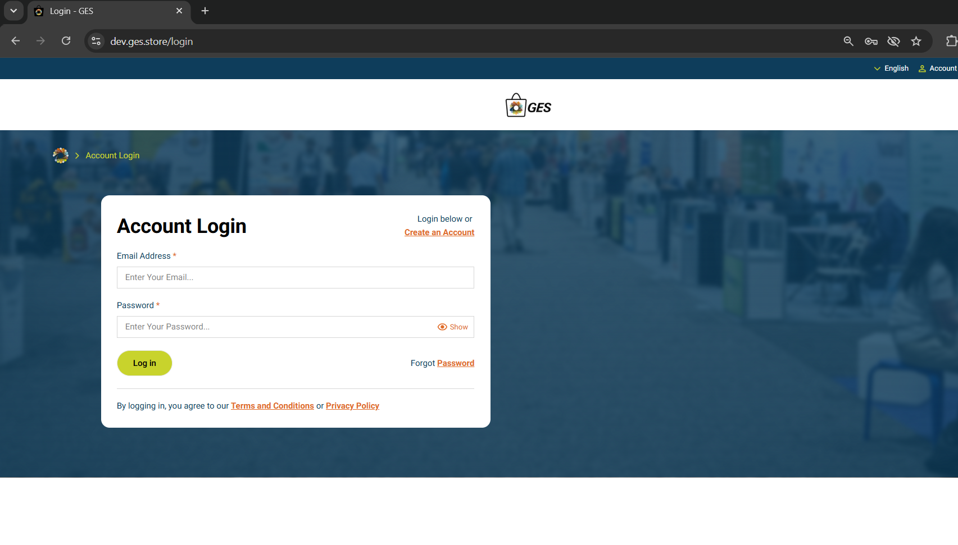

- Find or register a booth
- Manage booth information
- Order event services, including:
  - Furniture
  - Carpeting
  - Electrical
  - Internet
  - Graphics
  - Labor
  - Material Handling
  - Shipping (based on event availability)
- View event-specific pricing
- View event deadlines
- Validate Early Bird discounts
- Manage shopping cart
- Checkout and place orders
- Review order history
- View order confirmations
- Manage multiple booths under a single account
- User profile and account management
- Logout and session management

Important Notes
- The application initially displays a Secure Password Page before users can access the application.
- Do not create test cases for the Secure Password Page.
- Test case generation should begin from the Show Search Page after the secure password has been entered successfully.

Application Flow
URL: <Application URL>

Step 1 – Secure Password Page
The user enters the secure password to access the application.
Note:
- Do not create test cases for this page.
- Assume the user has already entered the correct password and successfully accessed the application.

Step 2 – Show Search Page
After entering the secure password, the Show Search page is displayed.
Create comprehensive test cases covering:
Functional Testing
- Show search
- Partial search
- Exact search
- Search using special characters
- Search using numbers
- Search using spaces
- Search using invalid values
- No matching results
- Multiple matching results
- Selecting a show
- Opening show details
- Navigation to Login page
UI Validation
- Page layout
- Labels
- Buttons
- Icons
- Fonts
- Colors
- Alignment
- Images
- Branding
Validation
- Mandatory fields
- Search validations
- Maximum character limits
- Minimum character limits
Negative Testing
- Invalid inputs
- Empty search
- Unsupported characters
- SQL Injection
- XSS validation
Boundary Testing
- Maximum search length
- Minimum search length
- Special character combinations
Performance
- Search response time
- Large result sets
- Page loading time
Accessibility
- Keyboard navigation
- Screen reader support
- Tab order
- Color contrast
- Focus indicators
Compatibility
- Chrome
- Edge
- Firefox
- Safari (if supported)
Responsive Testing
- Desktop
- Tablet
- Mobile
Error Handling
- Server unavailable
- Network interruption
- Timeout
- Error messages

Step 3 – User Login Page
After selecting a show, the User Login page is displayed.
Create comprehensive test cases covering:
Functional Testing
- Valid login
- Invalid username
- Invalid password
- Invalid username and password
- Empty username
- Empty password
- Empty username and password
- Email format validation
- Password masking
- Copy/Paste validation
- Remember Me functionality
- Forgot Password
- Session timeout
- Multiple browser sessions
- Logout functionality
- Re-login
- User role validation (Exhibitor and Third-Party)
Security Testing
- Account lockout after multiple failed attempts
- SQL Injection
- Cross-Site Scripting (XSS)
- Session fixation
- Session expiration
- Unauthorized access
- Browser back-button validation after logout
UI Validation
- Labels
- Buttons
- Links
- Placeholders
- Alignment
- Branding
- Error message placement
Validation Testing
- Mandatory fields
- Maximum length
- Minimum length
- Supported email formats
Negative Testing
- Invalid credentials
- Special characters
- Blank values
- Invalid email formats
Boundary Testing
- Maximum username length
- Maximum password length
- Minimum password length
Accessibility
- Keyboard navigation
- Tab sequence
- Screen reader compatibility
- Focus indicators
Compatibility Testing
- Chrome
- Firefox
- Edge
- Safari (if applicable)
Responsive Testing
- Desktop
- Tablet
- Mobile
Error Handling
- Authentication failures
- Server errors
- Network interruption
- Timeout scenarios
- Appropriate error messages

Remaining Modules
After successful login, create comprehensive test cases for every module in the application, including but not limited to:
- Dashboard
- Booth Registration
- Booth Management
- Multiple Booth Management
- Exhibitor Profile
- Third-Party User Profile
- Product Catalog
- Product Search
- Product Details
- Category Navigation
- Shopping Cart
- Checkout
- Payment
- Shipping
- Material Handling
- Furniture Ordering
- Electrical Services
- Internet Services
- Graphics Ordering
- Labor Services
- Pricing Validation
- Early Bird Discount Validation
- Taxes
- Coupons and Promotions
- Order Confirmation
- Order History
- Invoice Generation
- Download/Print Confirmation
- Notifications
- User Settings
- Account Management
- Help/Support
- Logout

General Test Coverage
For every page and feature, generate test cases covering:
- Functional Testing
- UI Testing
- Field Validation
- Positive Scenarios
- Negative Scenarios
- Boundary Value Analysis
- Error Handling
- Security Testing
- Accessibility Testing
- Cross-Browser Testing
- Responsive Testing
- Performance Testing
- Integration Testing
- End-to-End Testing
- Regression Testing
- Smoke Testing
- User Role-Based Testing (Exhibitor and Third-Party User)
Ensure that every feature includes normal, edge, invalid, and exception scenarios to achieve maximum test coverage.

